Instructions for filling out a time sheet for approved Mini-Grants
(October 15, 2012)

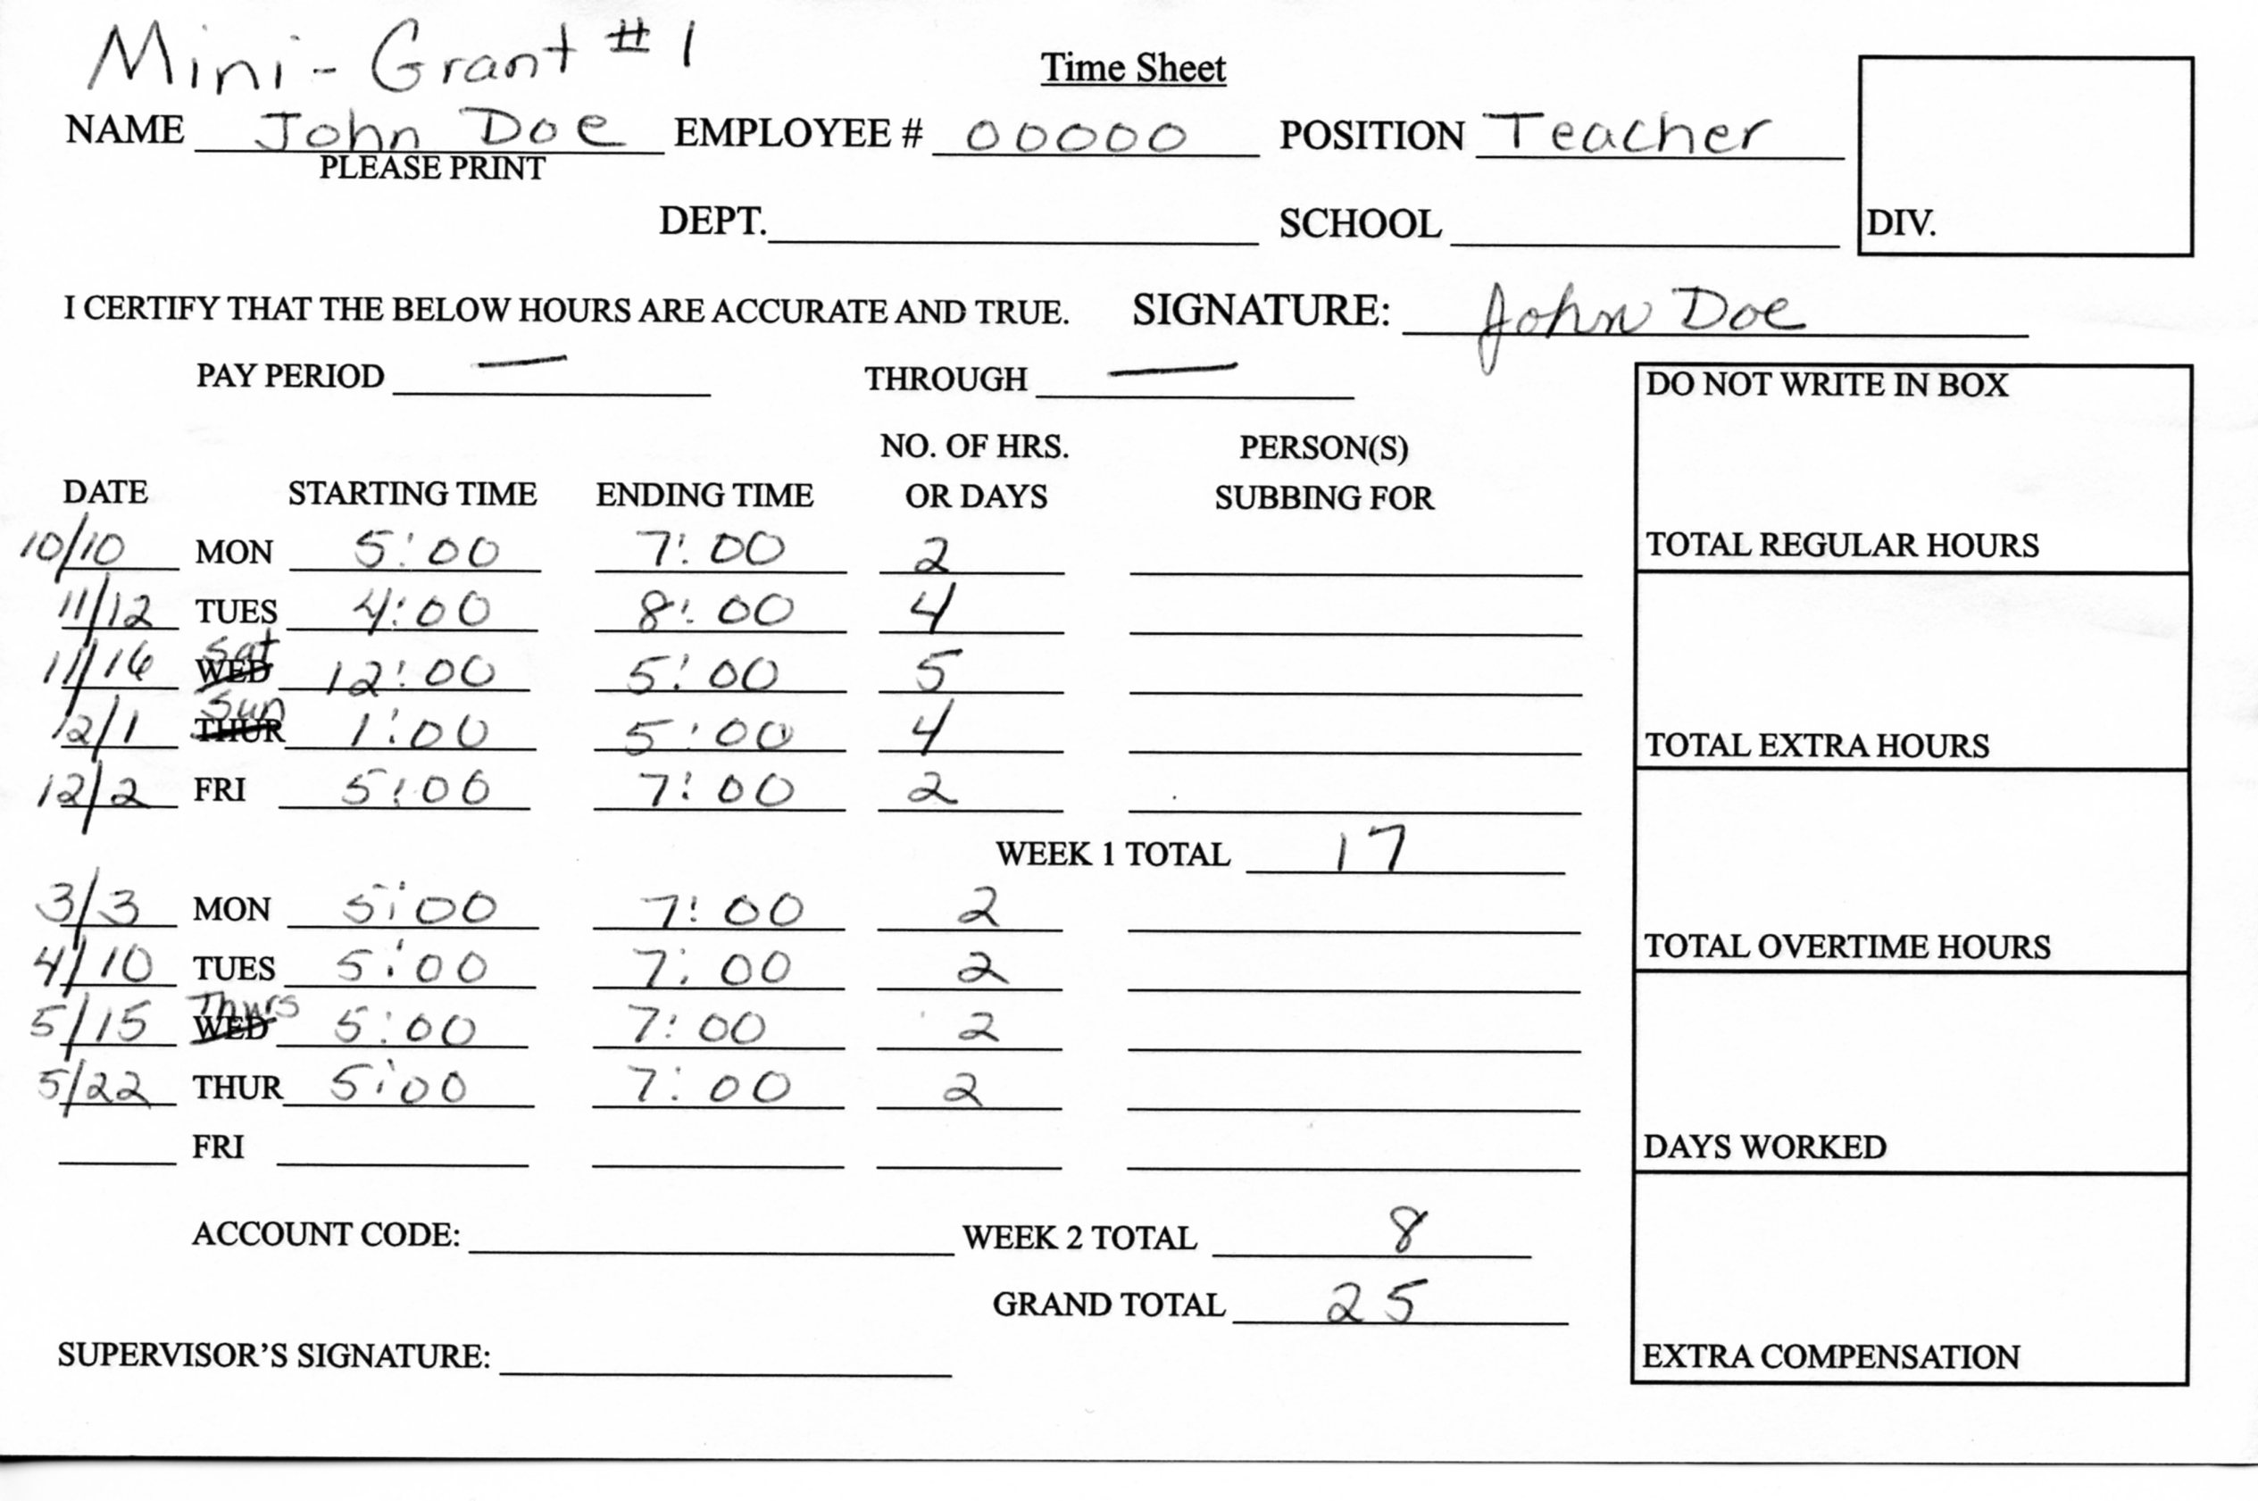

- Time sheets are available from the Payroll Office or outside the Payroll Office in hallway T at the Foreman Center. (Sometimes they can be obtained from your Department’s office.)
- Remember the hours worked must be outside your normal work day hours.
- Remember you may only submit for the amount of hours that you were approved for. You will be paid at the rate that you were approved for even if your position changes.
- Time sheets can be submitted anytime.
- Remember only 30% of the approved monies can be collected while working on the Mini-Grant. The remaining 70% can be collected after the final Mini-Grant is approved by the Mini-Grant Committee.
- Above is an example of a correctly filled out time sheet.
- Your employee number can be found on your paycheck as employee ID.
- Write the Mini-grant number on the top of the time sheet.
- You do not need to fill in pay period because you can list all your hours on one time sheet. It can include dates from different pay periods.
- Please check the following: included the Mini-Grant number, hours are correct and that you signed the time sheet. (Please note if there are errors it will be sent back.)
- DO NOT HAVE YOUR DIRECT SUPERVISOR SIGN IT.
- Make a copy for your records.
- Send filled out time sheet to designated Mini-Grant Co-Chair (Kathy Barrett, Foreman Center). The designated Mini-Grant Co-Chair will check for accuracy and then initial the time sheet. It is then sent to the Mini-Grant Treasurer (Ryanna Dimick) who will check for accuracy, prior to forwarding it to the appropriate people.
- If you have any questions regarding time sheets or payment please email the Mini-Grant Treasurer (Ryanna Dimick) who will then contact the appropriate people.

