Business Cards That Work
Your business card is one of the most important marketing tools you'll ever create. You give your business card to prospects and customers so they have your contact information. You tuck your business card inside of presentation folders, drop it in letters, and use it in a myriad of other ways to let people know who you are and what you do. And, if you run ads in local newspapers, your business card may even double as camera-ready copy for the publication's "business card ad" pages.
Business cards are handy print materials used by people to exchange contact details with one another. Their small size makes it easier and faster to hand out contact information when needed. These cards contain a person or business’ name and other relevant information like the person or business' office address, telephone numbers, e-mail address and website. Over the years, business cards have proven just how vital they are to an entrepreneur's day-to-day transactions especially if he's always out on business trips.

But no matter how you use your business card, it won't be the marketing workhorse it should be unless it looks professional, is easy to read, and helps customers and prospects remember what you sell and why they should buy it from you.

Making all that happen on a document that is only 3½ inches wide and 2 inches deep is a tall order. But it can be done. Here are several suggestions to keep in mind before you design or redesign your business card.
Make your card readable
Use (or insist your designer uses) font sizes that are big enough to be easily readable without using a magnifying glass. Be sure the type color stands out against the background of the card, too. Light gray type on a white card makes it hard to distinguish letters and numbers. Remember, your goal isn't to produce a work of art. It's to produce a business card that clearly communicates what you do and how to reach you. If recipients can't read the contact information you'll lose sales.
Make your card stand out from the rest of the pack
Yes, your business card may wind up stuffed in a desk drawer with a stack of other business cards. Make it stand out from the rest by using bright colors, including your photo on the card, or using high gloss card stock. In this day and age, standing out from the rest is a necessity.
Have your business cards printed on good card-stock
If the card feels flimsy or looks like you printed it yourself on a cheap printer, it will leave people with impression that they are dealing with a small company that will disappear as soon as the owner finds a real job. Have your business card printed on good heavyweight business card stock.
** On the back you could make an appointment cart with client’s name, date of service, time and service

The following should be on your card: Eastern Monroe Career Center, Cosmetology Clinic, 41 O’Connor Road, Fairport, NY 14450, phone- 585- 383-6624, email- laurie_ewanyk@boces.monroe,edu, your name, student stylist, Open Thursday Morning- 8:20, If you are unable to keep your appointment, please contact us as soon as possible.
Other items that you might use if you have space: (sample) Offering cuts, colors, highlights, nails and facials.
Use color and designs that will follow through your entire portfolio.
Scoring:
- Complete accurate information
- No typos
- Readable
- Stand out- professional
- Creative
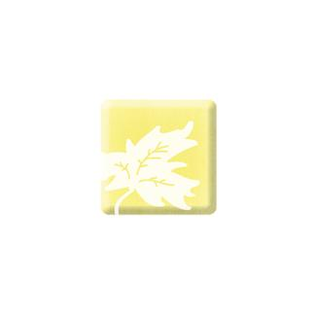
l
Eastern Monroe Career Center
Cosmetology Clinic
41 O’Connor Road
Fairport, NY 14450
585-383-6624
Open Thursday Mornings– 8:20

Mrs. Ewanyk
Student Stylist
Phone: 585-249-7207
E-mail: laurie_eweanyk@boces.monroe.edu

Enter at the Green Awning

If you are unable to keep your appointment, please contact us as soon as possible.

