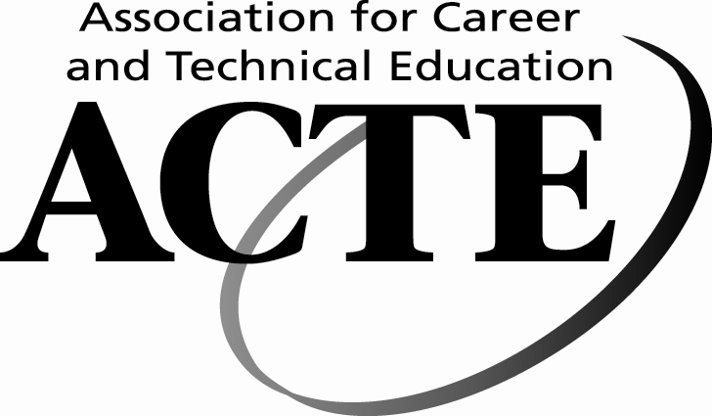
Facts About Career and Technical Education

Career and Technical Education (CTE) is crucial to providing the strong workforce training needed to fill the good-paying jobs vital to restoring the economic health of our nation. CTE programs also produce strong educational returns, strengthening student engagement in school, achievement in academics and technical skills, and transitions from high school to postsecondary education and from education to careers.

CTE-Related Jobs Are in High Demand
- According to the Georgetown University Center on Education and the Workforce, 30% of the 46.8 million job openings created by 2018 will require some college or a two-year associate degree. (Carnevale, Anthony, et al, Help Wanted: Projections of Jobs and Education Requirements Through 2018, Center on Education and the Workforce, Georgetown University, 2010, p. 13)
- The Bureau of Labor Statistics (BLS) projects that middle-skill jobs (jobs that generally require some significant education and training beyond high school but less than a bachelor’s degree) will account for about 45% of all job openings projected through 2014. (BLS, Occupational Outlook Handbook, 2010-2011 Edition)
- Of the occupations requiring postsecondary education, those requiring an associate degree are projected to grow the fastest, at about 19 percent. (BLS, Occupational Outlook Handbook, 2010-2011 Edition)
- Nearly one in six “hot jobs,” jobs paying above the median wage and having above average growth, will require an associate degree or some postsecondary training. (American Association of Community Colleges)
- By 2018, the U.S. will need at least 4.7 million new workers with postsecondary certificates, according to the Georgetown University Center on Education and the Workforce. (Carnevale, Anthony, et al, Help Wanted: Projections of Jobs and Education Requirements Through 2018, Center on Education and the Workforce, Georgetown University, 2010, p. 1)
CTE Meets Individual and Community Economic Needs

- Participation in skills-training programs increased wages and earnings, raised the probability and consistency of employment, and led to work in higher-quality jobs, according to Public/Private Ventures. (Maguire, Shiela, et al, Job Training That Works: Findings from the Sectoral Employment Impact Study, 2009)
- A person with an associate degree or two year credential will earn, on average, over $5,000 a year more than a person with just a high school diploma and a person with a CTE-related associate degree or credential will earn between $5,000 and $15,000 more a year than a person with a humanities or social sciences associate degree. (Jacobson, L., et al, Pathways to Boosting the Earnings of Low-Income Students by Increasing Their Educational Attainment, Gates Foundation/Hudson Institute, 2009)
- According to the Georgetown University Center on Education and the Workforce, 43% of young workers with Licenses and Certificates earn more than those with an associate degree, 27% of young workers with Licenses and Certificates earn more than those with a bachelor’s degree, and 31% of young workers with associate degrees earn more than those with a bachelor’s degree. (Center on Education and the Workforce, Valuing Certificates, Presentation, 2009)
- According to the Florida Department of Education, recent graduates who earned a career-focused associate degree or postsecondary certificate from a Florida community college are earning up to $11,000 more than bachelor's degree recipients from the state's eleven public universities. (Florida Department of Education, 2011)
- According to the state of Washington, for every dollar spent on secondary CTE students, federal and state governments will receive seven dollars back in social security, Medicare and federal and state taxes. (Washington State Workforce Training and Education Coordinating Board, Workforce Training Results-2006, January 2007)
CTE Engages Students and Lowers the Dropout Rate
- In a 2009 report for the Gates Foundation, 81% of respondents said that more learning opportunities which make the classroom relevant to the real world would have helped them to finish high school. (Bridgeland et al, The Silent Epidemic: Perspectives of High School Dropouts, Bill and Melinda Gates Foundation, 2006)
- A ratio of one CTE class for every two academic classes minimizes the risk of students dropping out of high school. (Plank, S. et al, Dropping Out of High School and the Place of Career and Technical Education, The National Centers for Career and Technical Education, 2005)
- The more students participate in Career Technical Student Organization activities, the higher their academic motivation, academic engagement, grades, career self-efficacy and college aspirations—factors often linked to high school graduation. (Alfeld, C., et al., Looking Inside the Black Box: The Value Added by Career and Technical Student Organizations to Students’ High School Experience, National Research Center for CTE, 2007)
CTE Increases Student Achievement
- Students using the National Research Center for CTE’s Math-in-CTE model, which uses highly integrated CTE and academic teaching methods and courses, scored significantly higher on two national math assessments than students using traditional teaching methods. (Stone, J., et al., Building Academic Skills in Context, National Research Center for CTE, 2006)
- Students who complete a rigorous academic core coupled with a career concentration have test scores that equal or exceed “college prep” students. These dual-concentrators are more likely to pursue postsecondary education, have a higher grade point average in college and are less likely to drop out in the first year. (Southern Regional Education Board, “Facts About High School Career/Technical Studies”)
- CTE students were significantly more likely than their non-CTE counterparts to report that they had developed problem-solving, project completion, research, math, college application, work-related, communication, time management and critical thinking skills during high school. (Lekes, N., et al., Career and Technical Education Pathway Programs, Academic Performance, and the Transition to College and Career, National Research Center for CTE, 2007)
- Students in programs that blend basic skills and occupational training to generate more contextualized learning are far more likely to improve basic skills and earn college-level credits, according to researchers at the Community College Research Center at Columbia University’s Teachers College. (Jenkins, David, et al., Educational Outcomes of I-BEST, Washington State Community and Technical College System’s Integrated Basic Education and Skills Training Program: Findings from a Multivariate Analysis, 2009)

