Ice Cream Cake
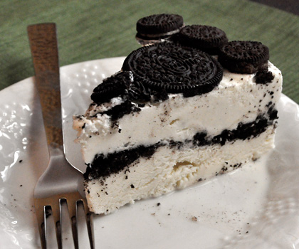
Ingredients

1 package of oreo cookies
1 jar of hot fudge sauce
1 gallon of your favorite ice cream

- Place oreos in a baggie and crush into small pieces.

- Place ¾ of oreos on bottom of baking pan, Press evenly into bottom of pan.

- Take ice cream out of container and cut length wise in half.

- Spread one half evenly on top of oreos in pan.

- Spread jar of fudge sauce on top of the ice cream.

- Spread other half of ice cream on top of fudge sauce layer.

- Sprinkle top with remaining oreos.

- Cover and place in freezer until ready to serve.

