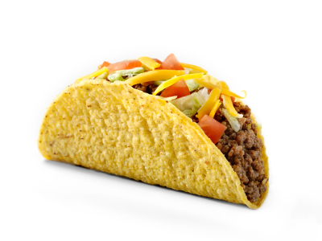**Ingredients**

1 lb. ground beef

8 ounce cheddar cheese shredded

½ head of iceberg lettuce shredded

3 ripe tomatoes diced

12 hard or soft taco shells

1 pkg. taco seasoning mix

¾ cup of water

**Directions**

1. Shred cheddar cheese and place in bowl.
2. Wash lettuce, drain, shred and place in bowl.
3. Wash tomatoes, dice (cut into small pieces) and place in bowl.
4. In a frying pan, over medium heat brown the ground beef.
5. Drain the ground beef using colander.
6. Place beef back in pan.
7. Add taco seasoning packet, water and mix.
8. Heat until thickened, stirring often.
9. Fill taco shells with meat mixture and toppings.