**Mixed Berry Muffins**

[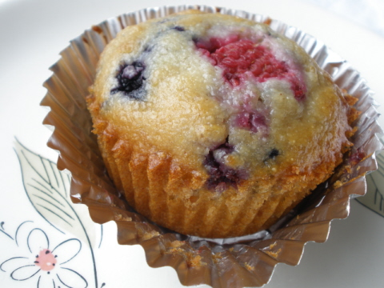](http://www.google.com/url?sa=i&rct=j&q=mixed+berry+muffins&source=images&cd=&cad=rja&docid=gw7Li8ZVNuC5MM&tbnid=y6BnC1-mxUs3RM:&ved=0CAUQjRw&url=http://justeatfood.com/n-822-three-grain-mixed-berry-muffins.html&ei=5l0UUcDFLc3p0QHd_oH4Bw&bvm=bv.42080656,d.dmQ&psig=AFQjCNFflBa3fm0JA0DHOhkxb2uC7XWwlQ&ust=1360375607091408)**Ingredients**

**Wet**

½ cups sour cream

½ cup milk

2/3 cup canola oil

2 eggs

1 teaspoon vanilla extract

**Dry**

2 cups flour

½ ground nuts

1 cup brown sugar

1 teaspoon baking powder

½ teaspoon baking soda

¼ teaspoon salt

**Others**

2 cups fresh or frozen berries of your choice

**Directions:**

Preheat oven to 375

Mix both wet and dry ingredients separately. Stir together until just blended. Do not over mix. Gently fold in mixed berries.

Scoop each muffin cup with ¾ full of batter, and bake until a toothpick inserted in the center comes out clean, about 20 minutes.

Let muffins cool in pan for 10 minutes.