Making Deviled Eggs

You will need 1 egg per person

Making an Egg Sandwich

You will need;

frying pan

1 egg

1 teaspoon of butter

1 slice of cheese

1 slice of ham or bacon

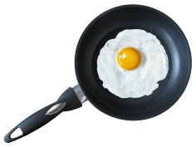2 slices of bread toasted or english muffin toasted

1. 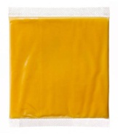Fry egg in pan
2. Place cheese on egg and melt

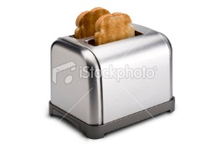

1. Toast bread or English muffin

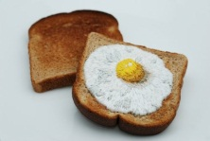

1. Place egg on bread or muffin
2. 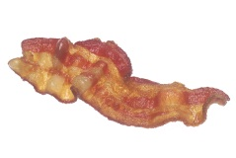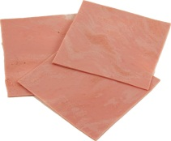Place ham or bacon on egg
3. Cover with other half of bread or muffin

Deviled Eggs

You will need:

Pan with water to boil eggs

1 egg per person

Small bowl

1 teaspoon mayonnaise

Drop of mustard

Dash of salt

Dash of pepper

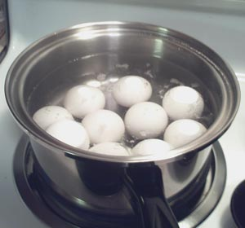

1. Boil eggs until hard



1. Cool eggs with cold water

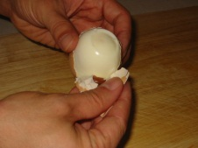

1. Peel egg

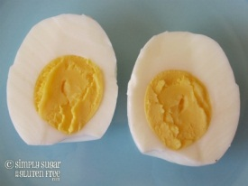

1. Cut egg lengthwise in half

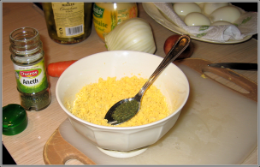

1. Slip out yolks into bowl
2. [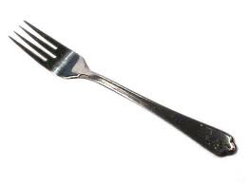](http://www.google.com/imgres?q=fork&um=1&hl=en&qscrl=1&nord=1&rlz=1T4ACAW_en___US420&biw=1249&bih=535&tbm=isch&tbnid=0zqLNQ6t6ea-RM:&imgrefurl=http://www.hometownsevier.com/daily-devotions/2011/01/28/woman-and-a-fork/&docid=GDbLGzmfGCXzlM&imgurl=http://www.hometownsevier.com/wp-content/uploads/2011/01/fork.jpg&w=450&h=338&ei=4IIfT9zgAYax0AG4krUG&zoom=1)Mash with fork
3. 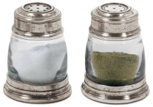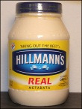Stir in mayonnaise, mustard, salt and pepper
4.  Fill egg whites with yolk mixture.

Egg Salad Sandwich

You will need:

Pan with water to boil eggs

2 eggs per person

Small bowl

1 tablespoon mayonnaise

Drop of mustard

Dash of salt

1. Boil eggs until hard



1. Cool eggs with cold water
2. Peel egg



1. Chop egg with chopper into bowl
2. 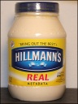[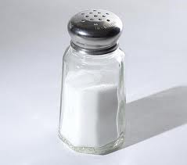](http://www.google.com/imgres?q=salt&hl=en&rlz=1T4ACAW_en___US420&biw=1249&bih=535&gbv=2&tbm=isch&tbnid=8x1g9nZQsKFUGM:&imgrefurl=http://blogs.plos.org/obesitypanacea/2010/10/06/how-much-salt-is-in-your-fast-food/&docid=piuNfmzd_q64JM&imgurl=http://blogs.plos.org/obesitypanacea/files/2010/10/SaltShaker.jpg&w=500&h=441&ei=cocfT-bjJ-Pr0gG83fAF&zoom=1&iact=hc&vpx=290&vpy=210&dur=49&hovh=211&hovw=239&tx=142&ty=233&sig=111053167154912029301&page=1&tbnh=136&tbnw=154&start=0&ndsp=12&ved=1t:429,r:7,s:0)Stir in mayonnaise, mustard, salt
3. Make sandwich