Hawaiian Chicken

[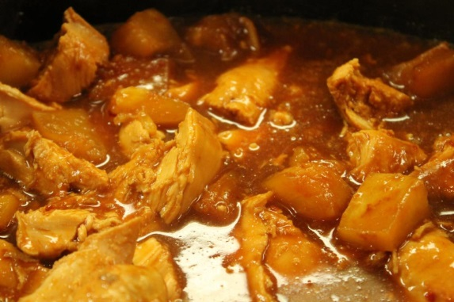](http://www.google.com/url?sa=i&rct=j&q=hawaiian+chicken&source=images&cd=&cad=rja&docid=OOCN9cR7Bsp2pM&tbnid=R5uCX2_3UCP7EM:&ved=0CAUQjRw&url=http://366daysofpinterest.com/2012/11/18/day-292-crock-pot-hawaiian-bbq-chicken/&ei=quNhUcOSGorO0QGK-IDYBA&psig=AFQjCNG93xQnCfFA54W2YX-z4lt_GAv-FA&ust=1365456057764902)Serves 6

Prep time 30 minutes

Ingredients

1 package Lipton Onion Soup Mix

1 cup (8oz.) apricot preserves

1 Tablespoon soy sauce

1 small bottle of Thousand Island dressing

6 boneless chicken breasts

Directions

1. Clean chicken breasts

2. Grease a 13 by 9 baking pan and place chicken breast in the pan.

3. In a medium size bowl mix the onion soup, apricot preserves, soy sauce and Thousand Island dressing together.

4. Pour the mixed ingredients over the chicken.

5. Bake 1 hour at 350 degrees.

6. Serve with white rice.