Cherry Pie

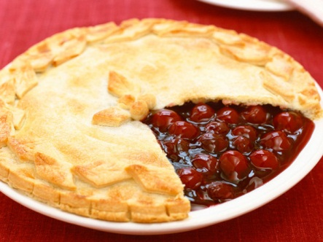**Ingredients**

2 (9 inch) pie crusts

3 16 oz. cans of cherry pie filling

1 TBLS. melted butter

Sugar

**Directions**

1. Preheat oven to 350

2. Put one prepared pie crust into 9 inch pie plate

3. Pour in cherry pie filling

4. Cover with prepared pie crust

5. Vent with fork or knife

6. Place butter in bowl, microwave for 30 seconds or until butter is melted

7. Brush over top pie crust

8. Sprinkle with sugar

9. Bake for 50 or 60 minutes or until pie has browned