**Meatballs**

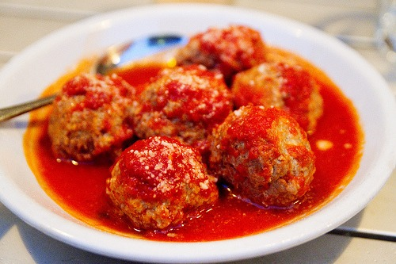**Prep Time:** 15 minutes

**Cook Time:** 30 minutes

**Total Time:** 45 minutes

**Yield:** 4 servings

**Ingredients:**

* 1 lb. lean ground beef
* 1 egg
* 2 Tbsp. water
* 1/2 cup bread crumbs
* 1/4 cup minced onion
* 1/2 tsp. salt
* 1/8 tsp. pepper

**Preparation:**

Preheat oven to 350 degrees. In large bowl combine egg, water, bread crumbs, onion, salt and pepper and combine. Add ground beef, broken into chunks, and mush with your hands to combine. Form into meatballs about 1" in diameter and place on a broiler pan. Bake at 350 degrees for 25-30 minutes until meatballs are no longer pink in center. Cool and freeze, or when baked, place in your favorite sauce.